Local economic recovery

Purpose of report
For discussion.

Summary
At its meeting on 27 October the Board received an update paper on economic recovery in relation to the impacts from the pandemic. The report set out the work that this and other LGA boards were commissioning as well as the broader improvement offer and which reflects the issues that are being raised with the LGA by councils. The Board discussed how we might prioritise our work on economic recovery and suggested some potential gaps, for example on specific sectors. This report outlines the macro, sectorial and geographic impact of the pandemic and associated restrictions. In order to inform the Board’s further thinking on what this means for local areas and the role of councils in responding to local impacts Robert Pollock, from Social Finance, has been invited to lead a discussion. Social Finance have been commissioned to develop good practice advice for councils on leading and planning local economic recovery.

Recommendation
The Board note the report; and
Discusses the issues raised in the report and in Robert’s presentation
Action
As directed by the Board

Contact officer: Kamal Panchal
Position: Senior Adviser
Phone no: 0207 664 3174
Email: kamal.panchal@local.gov.uk

Local economic recovery
Background
- At its meeting on 27 October the Board received an update paper on economic recovery in relation to the impacts from the pandemic. The report set out the work that the Board was commissioning as well as the broader improvement offer, some of which is bespoke support, and the work of other Boards in respect of economic recovery. This work reflects the issues that are being raised with the LGA by councils. The Board discussed how we might prioritise our work on economic recovery and suggested some potential gaps, for example on specific sectors.
- One of the Board’s commissions is seeking to provide support and learning as councils develop and revise economic recovery plans. This work is being carried out by Robert Pollock from Social Financing. Robert has been invited to provide an overview on councils’ economic recovery plans; providing a basis for the Board to discuss the future work that it can do to: influence the national framework around economic recovery; and support councils in their efforts to revive local economies.
Issues
- The COVID-19 pandemic continues to impact on local economies for which the full effects are yet to be felt. The Office for Budget Responsibility’s (OBR’s) forecast expects GDP to shrink by 11.3 per cent in 2020 – the largest annual fall since 1709.
- The OBR forecast draws out at a macro level the differential economic shocks to sectors. Sectors most reliant on face-to-face interactions, such as hospitality, transport, and entertainment, saw the biggest falls in activity as they were most directly affected by public health restrictions and the difficulties in implementing social distancing. By contrast, sectors that were largely able to continue to operate while adhering to social distancing rules, such as financial services, energy, and agriculture, have been spared the worst economic consequences of the pandemic.
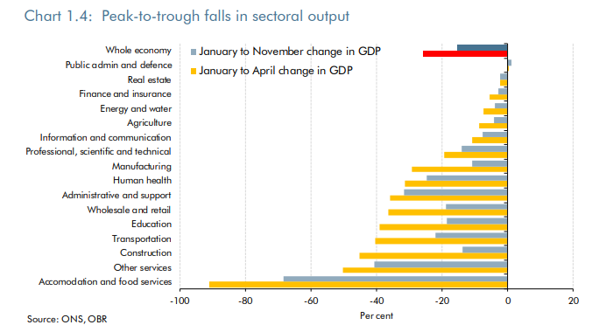
- Other expert commentators have gone further with their analysis. For example, ADEPT (Association of Directors of Economy, Environment, Planning and Transport) and EY have published a report exploring why local areas will be affected in different ways through lockdowns based on their local economic structure.
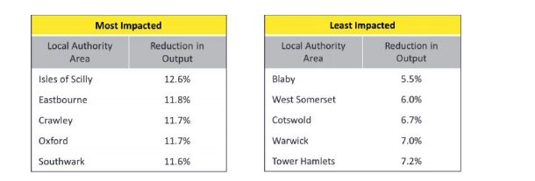
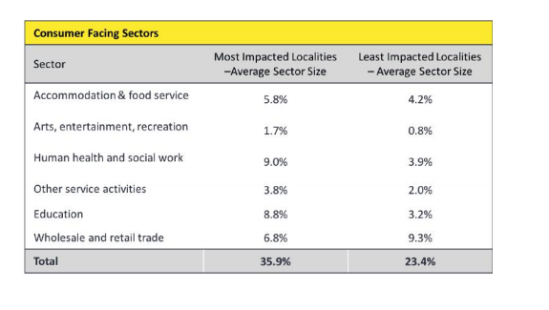
- The above tables illustrate how the most affected local areas are forecast to experience double the reduction in economic output than the least impacted and how the average size of consumer facing sectors is far higher for the most impacted local authority areas compared with those least impacted.
- The report goes on to explore the levers and potential responses that are available to local leaders in responding to the challenges posed by local lockdowns:
- Challenges
  - Economic output is reduced during lockdown with the scale of impact primarily driven by the structural economic composition of localities.
  - Local lockdowns most acutely impact sectors that require face to face interaction to function.
  - Local lockdowns reinforce existing economic challenges within localities.
  - Interventions need to empower local areas, be sector specific and recognise dependencies on other forms of local and national support plans.
  - Consumer and business confidence is fragile and responsive to pessimistic communications and business sentiment.
- Responses should:
  - Scope and prioritise interventions that sustain or enhance economic supply, specific to sectors.
  - Act quickly to sustain or enhance economic demand with targeted interventions that focus on enabling demand to access supply.
  - Local areas work in synergy within their regions to seize opportunities and collaborate around risk.
  - Form and leverage alliances, partnerships and working groups that can rapidly broker local intelligence on business, employment and skills, and consequently expedite support and ensure synergy with other plans.
  - Develop a coherent, well evidenced narrative for both government and business that instils confidence and trust, specific to a local area.
- The work that the LGA has commissioned Social Finance to do over the coming weeks will complement the work of expert commentators by drawing out the practical considerations and steps that councils should be taking in supporting and sustaining local economic recovery. Social Finance’s work on this will involve speaking to a wide range of councils and good practice advice will be targeted to specific stakeholders, such as elected members.
Biography
Robert Pollock is a Director at Social Finance. He has over 20 years of public sector experience, is a former Treasury official, and has recently supported authorities to develop scenario plans to inform social and economic recovery strategies, and is a regular contributor to the local government trade press.
Implications for Wales
- Local growth is a devolved matter for Wales; however the learning from the work commissioned by the LGA will be of benefit to Welsh Councils.
Financial Implications
- There are no specific financial implications as a result of this work.
Next steps
- Recommendation/s
  - The Board note the report; and
  - Discusses the issues raised in the report and in Robert’s presentation

- Action
  - As directed by the Board

